第7次作业 (第9章)

危国锐 516021910080

（上海交通大学电子信息与电气工程学院，上海200240）

摘要：第7章作业. 截止日期：2022-05-13.

关键词：关键词1，关键词2

Homework 7 (Chapter 9)

Guorui Wei 516021910080

(*School of Electronic Information and Electrical Engineering*,  
*Shanghai Jiao Tong University*, *Shanghai* 200240, *China*)

**Abstract****:** Selected exercises in chapter 9. Due date: May. 13th, 2022.

**Keywords:** keyword 1, keyword 2

**目 录**

摘要 i

Abstract i

1 Chapter 9 1

1.1 How does the method of dating climate records vary with the type of archive? 1

1.2 How does the resolution from sedimentary archives vary with depositional environment? 1

1.3 How do the processes that control δ18O changes in ice sheets differ from those that control δ18O fluctuations in ocean cores? 1

1.4 What climate factors affect the removal of CO2 from the atmosphere by chemical weathering? 2

1.5 Where did the extra CO2 from Earth’s early atmosphere go? 2

1.6 What is the central concept behind the BLAG (spreading rate) hypothesis? 2

1.7 The volume of water in the world ocean is 48.5 times larger than the amount stored in the two largest ice sheets. The average δ18O value of the ocean is near zero, while the mean δ18O value of ice on Antarctica and Greenland is 250‰. Show a calculation indicating how much the mean δ18O value of ocean water would decrease if the two ice sheets melted. 3

1.8 Why does Earth have seasons? 3

1.9 When is Earth closest to the Sun in its present orbit? How does this “close pass” position affect the amount of radiation received on Earth? 4

1.10 Do insolation changes during summer and winter have the same or opposite timing at any single location on Earth? Why or why not? 4

1.11 In what way is the orbital monsoon hypothesis an extension of processes driving modern monsoons? 5

1.12 What is the best method of measuring the melting of ice sheets over the last 17,000 years? 6

References 7

# Chapter 9

## How does the method of dating climate records vary with the type of archive?

（1）放射性定年法（radiometric dating）：利用放射性物质的半衰期；

（2）年层（Annual Layers）：冰盖，沉积物，树，珊瑚；

（3）根据轨道参数定年（Correlating Records with Orbital Cycles）：利用太阳辐射强度与物理过程的固定关系：如低纬度季风和高纬度冰盖的周期性.

## How does the resolution from sedimentary archives vary with depositional environment?

沉积物的分辨率取决于：（1）沉积速率，（2）扰动（在不同的环境中，移动穿过和钻入沉积物表面的生物体的干扰程度不同）.

沉积速率越快、扰动越小，则分辨率越高.

## How do the processes that control δ18O changes in ice sheets differ from those that control δ18O fluctuations in ocean cores?

冰盖中的δ18O主要通过蒸发-凝结降水的“分馏”机制，由**温度**控制. 温度越高，冰盖中的δ18O越少. 一图说明（图源：2022-04-24课件第5页）：

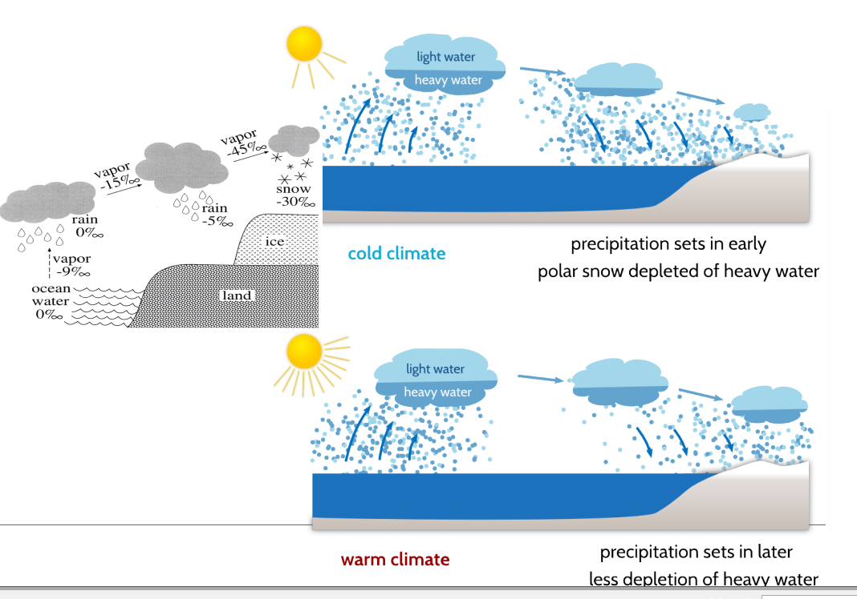

海洋中的δ18O仍主要通过蒸发-凝结降水的“分馏”机制，由**蒸发减降水量**控制. 净蒸发量越高，海洋中的δ18O越高. 由于盐度也由蒸发减降水量控制，与δ18O基本上同向变化，故二者的空间分布类似.

## What climate factors affect the removal of CO2 from the atmosphere by chemical weathering?

温度，降水和植被这三个气候因素影响~. 三个因素通常正相关. 一图说明（图源：2022-04-24课件第29页）：

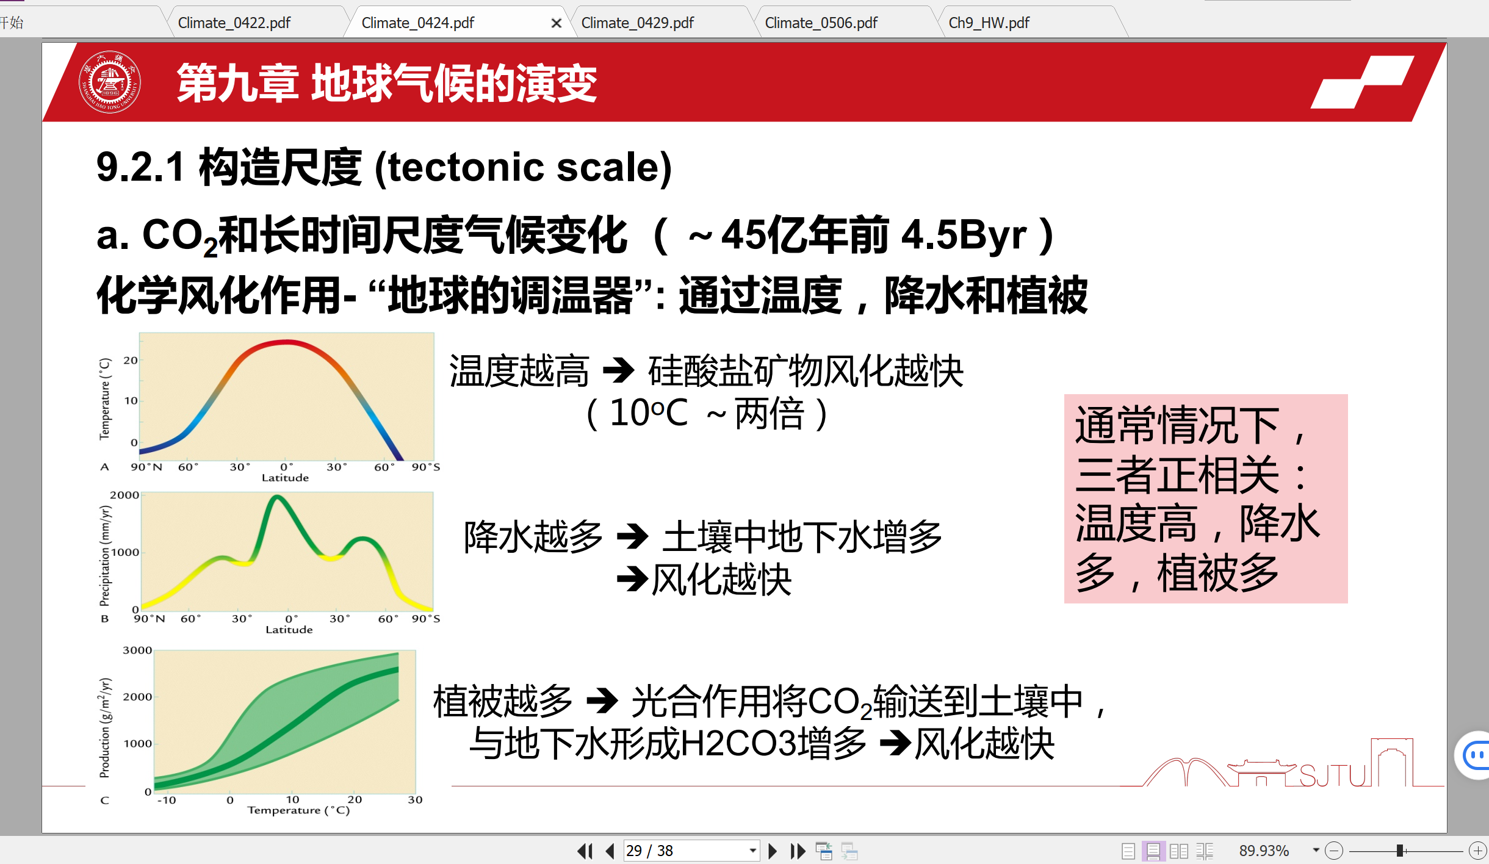

## Where did the extra CO2 from Earth’s early atmosphere go?

风化形成碳酸盐和硅酸盐，溶解在地表径流，输入海洋，形成碳酸盐和硅酸盐颗粒沉入深海封存.

## What is the central concept behind the BLAG (spreading rate) hypothesis?

大气CO2浓度由平均海底扩张速度驱动. 海底扩张速度增快 -> 更多火山活动 -> 更多大气CO2.

concept *behind*? 风化负反馈机制？

## The volume of water in the world ocean is 48.5 times larger than the amount stored in the two largest ice sheets. The average δ18O value of the ocean is near zero, while the mean δ18O value of ice on Antarctica and Greenland is 250‰. Show a calculation indicating how much the mean δ18O value of ocean water would decrease if the two ice sheets melted.

The mean δ18O value of ocean water would decrease by 250‰×1 / (1 + 48.5) = 5.05‰ if the two ice sheets melted.

## Why does Earth have seasons?

因为地球的自转轴是倾斜的. 一图说明（图源：2022-04-29课件第18页）：

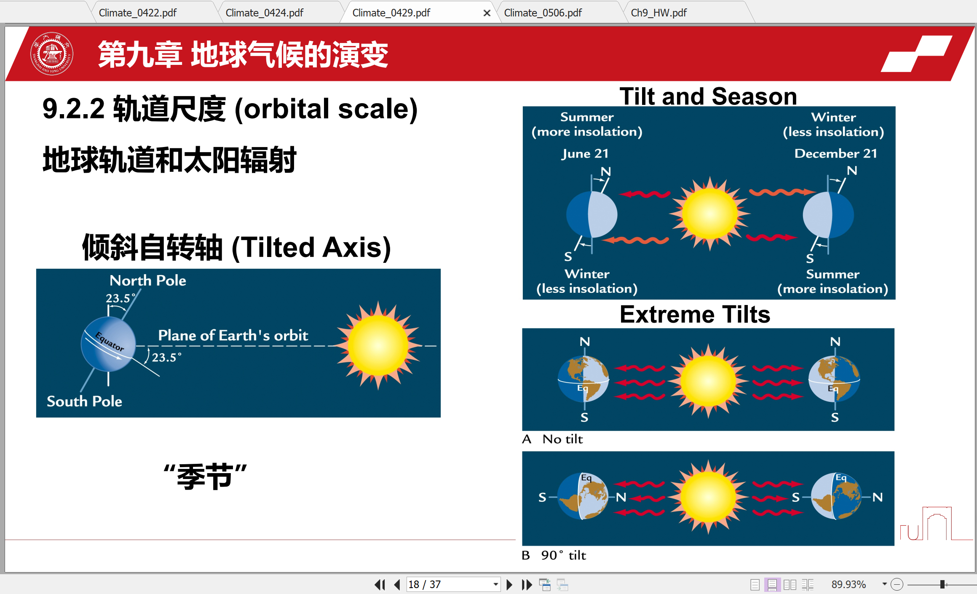

## When is Earth closest to the Sun in its present orbit? How does this “close pass” position affect the amount of radiation received on Earth?

当前近日点在1月3日左右. 当前的近日点在北半球冬至附近，导致北半球的冬季辐射和南半球的夏季辐射比完全圆形轨道上的辐射略强. 一图说明（图源：2022-04-29课件第20页）：

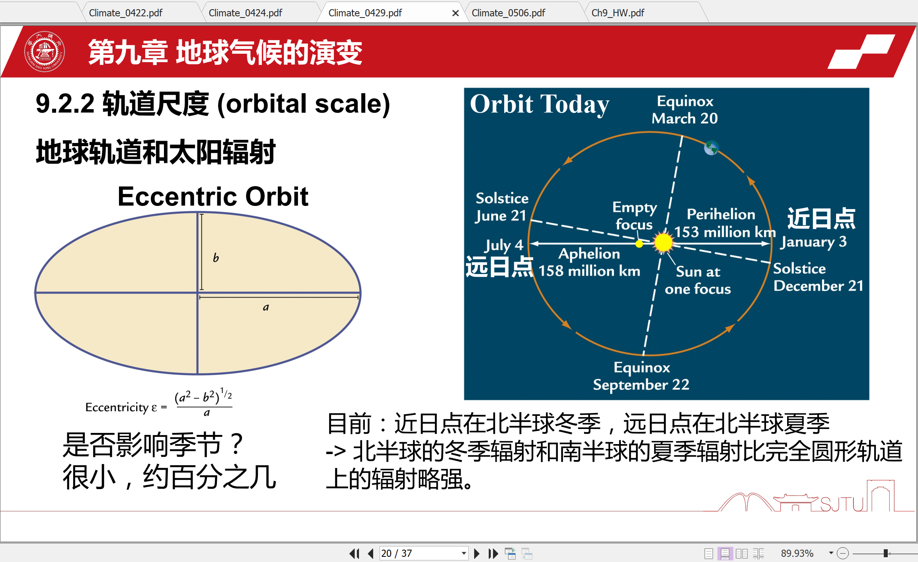

## Do insolation changes during summer and winter have the same or opposite timing at any single location on Earth? Why or why not?

否. 地球轨道的三个参数——偏心率（Eccentricity: Eccentric Orbit），黄赤交角（Obliquity: Tilted Axis）和岁差（Precession）会影响到达地球的太阳辐射. 偏心率的影响在南北半球同相，但岁差的影响在南北半球是反相的.

一图说明（图源：2022-04-29课件第30页）：

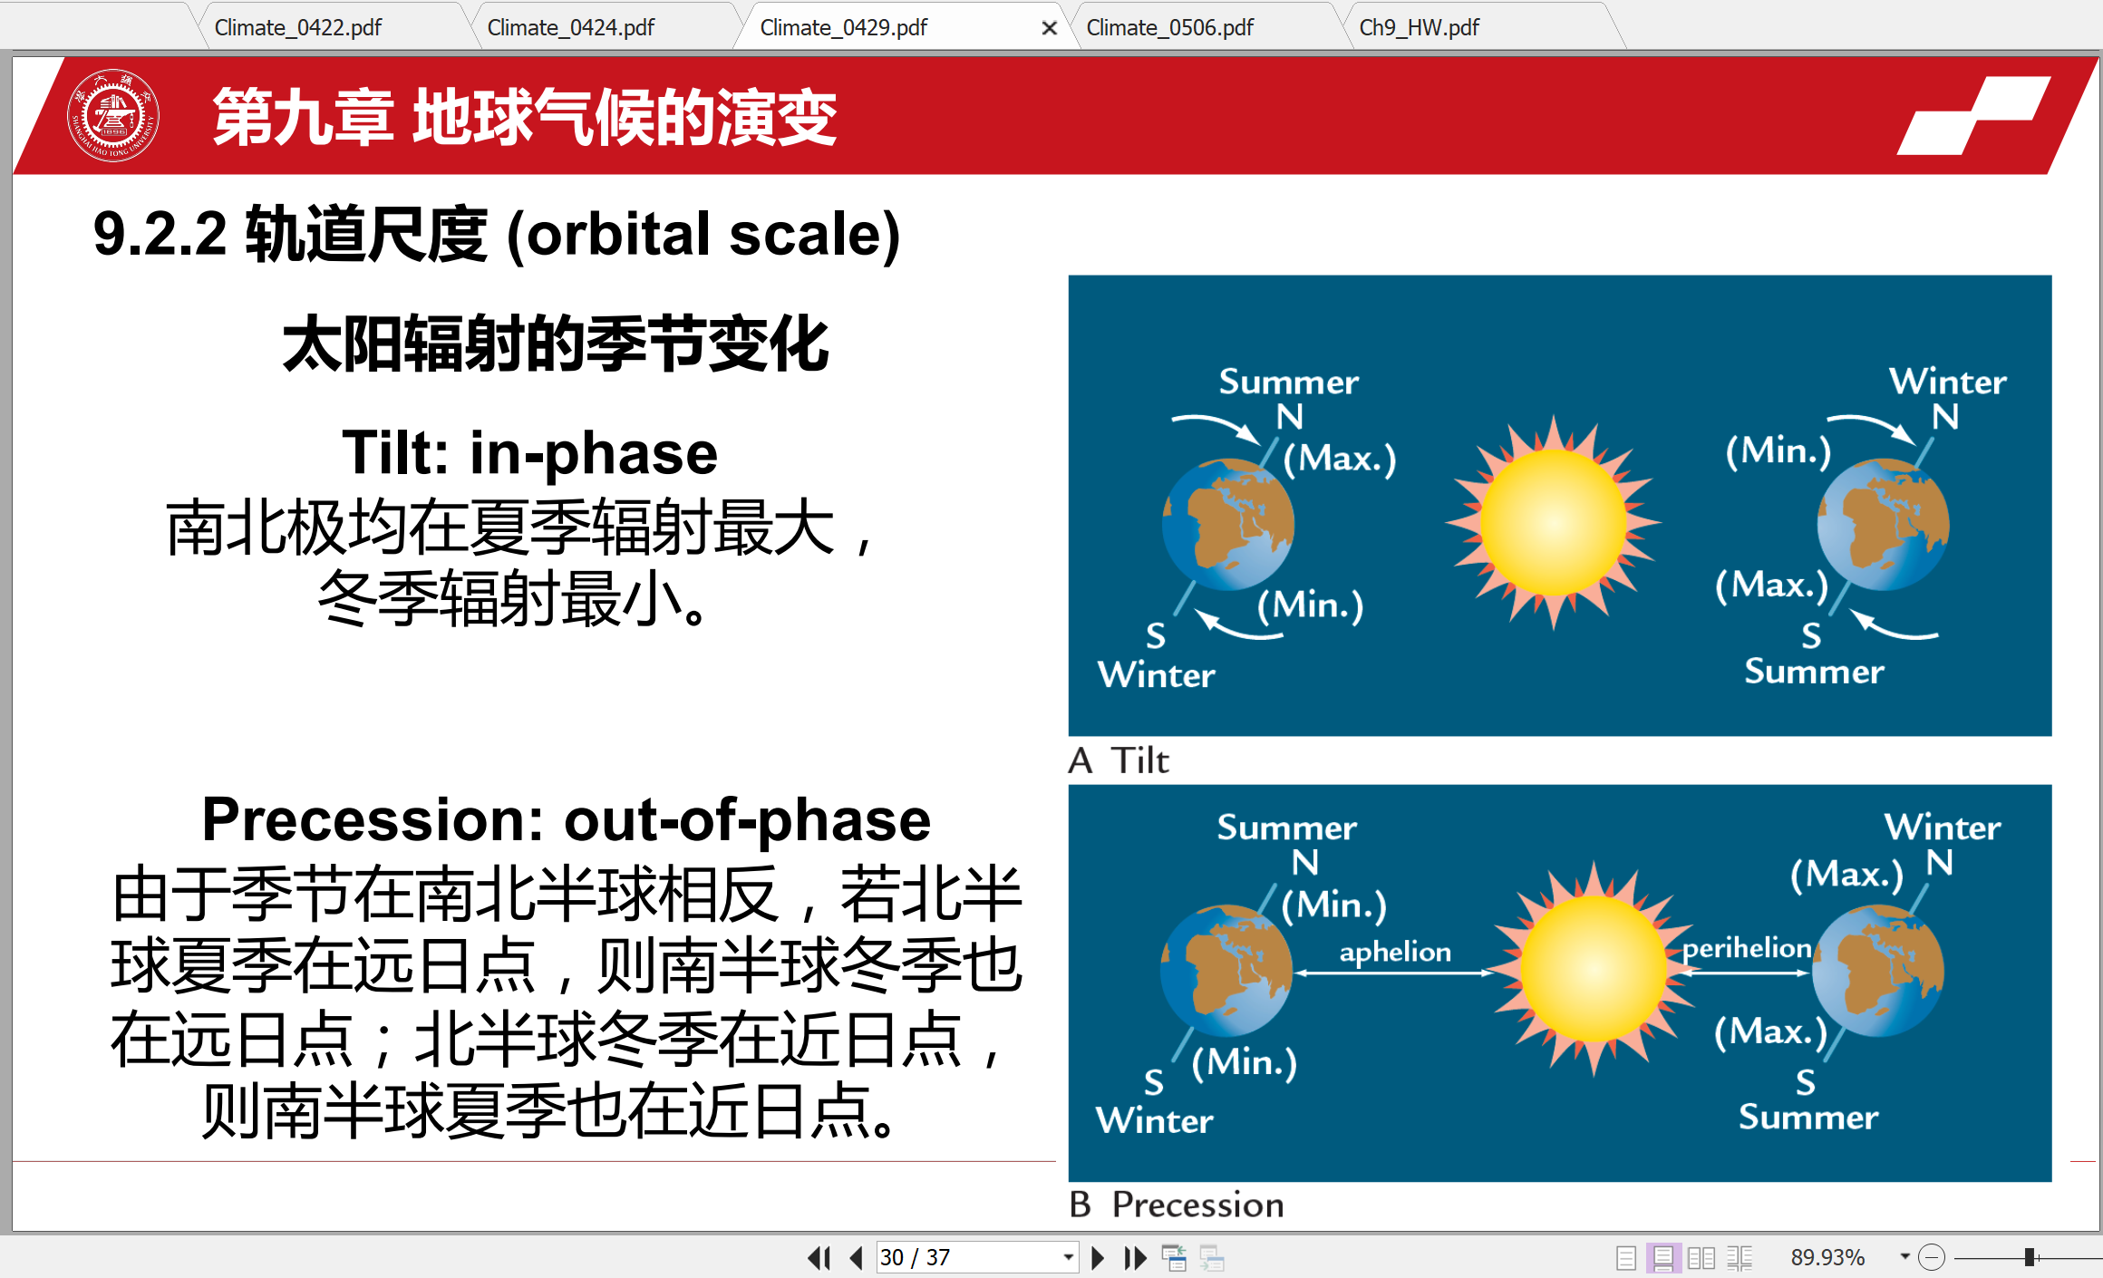

## In what way is the orbital monsoon hypothesis an extension of processes driving modern monsoons?

现代季风形成机制之一是“大型海陆风”学说. 若地球轨道参数配置使得夏季辐射更强（弱）且冬季辐射更弱（强），例如夏至日位于近日点附近时，则夏季风和冬季风都加强.

一图说明（图源：2022-04-29课件第33页）：

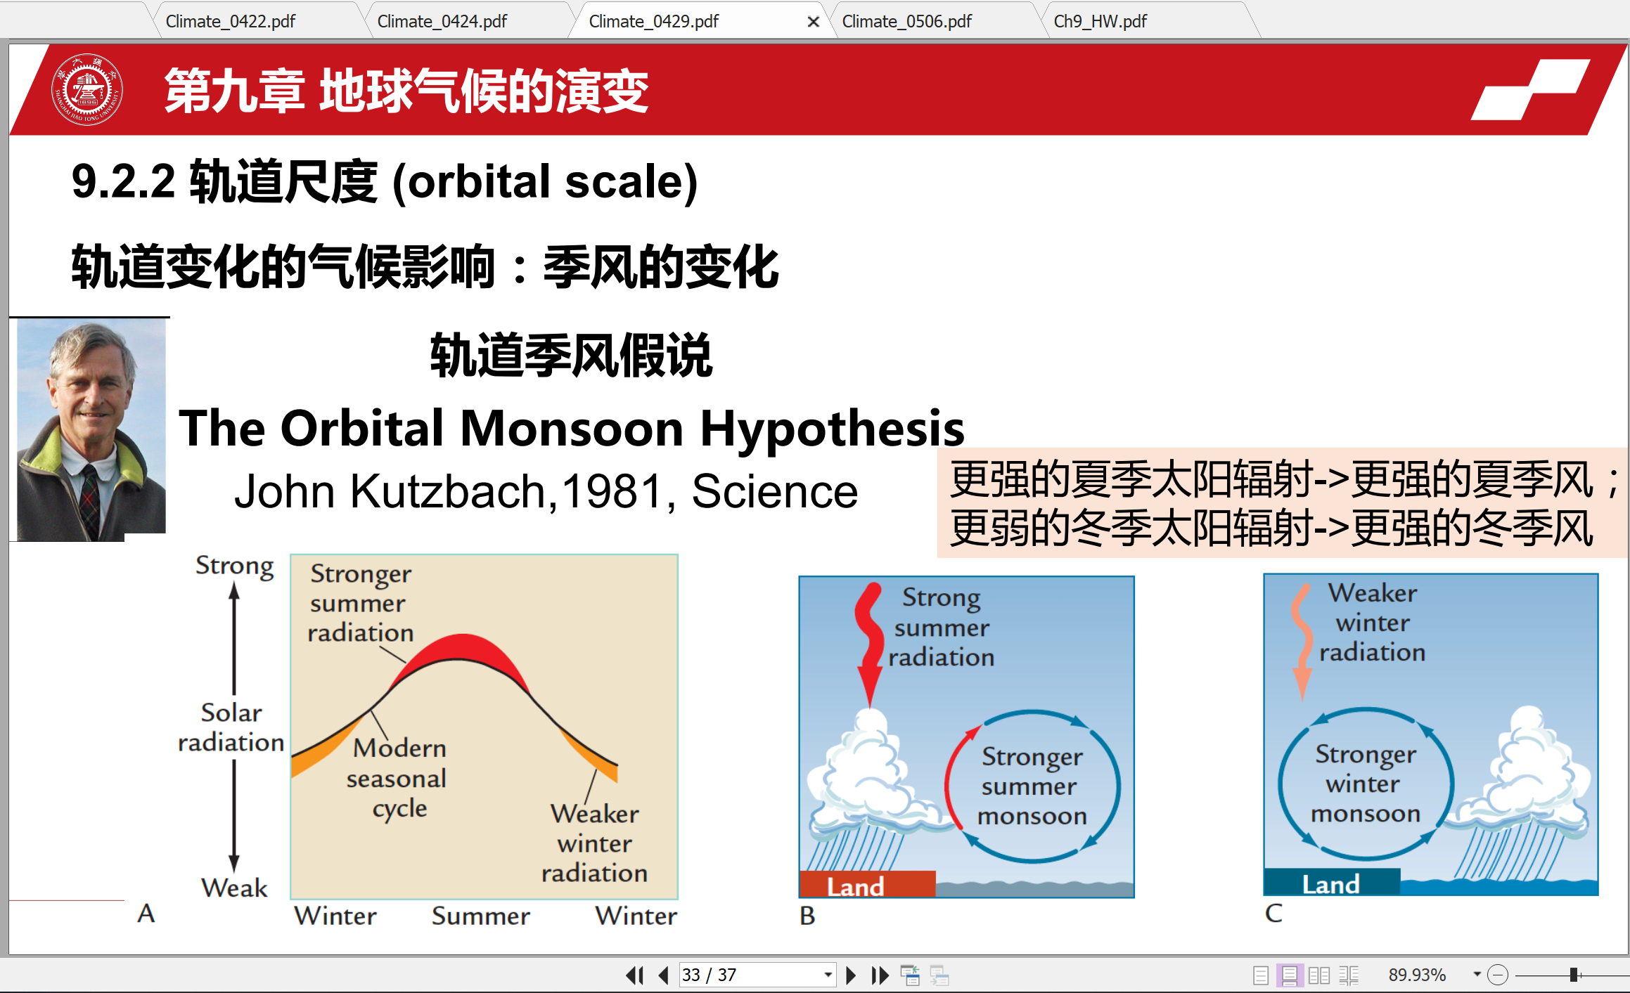

## What is the best method of measuring the melting of ice sheets over the last 17,000 years?

用海洋沉积物的δ18O推算（下图所示，图源：2022-04-24课件第8页）？

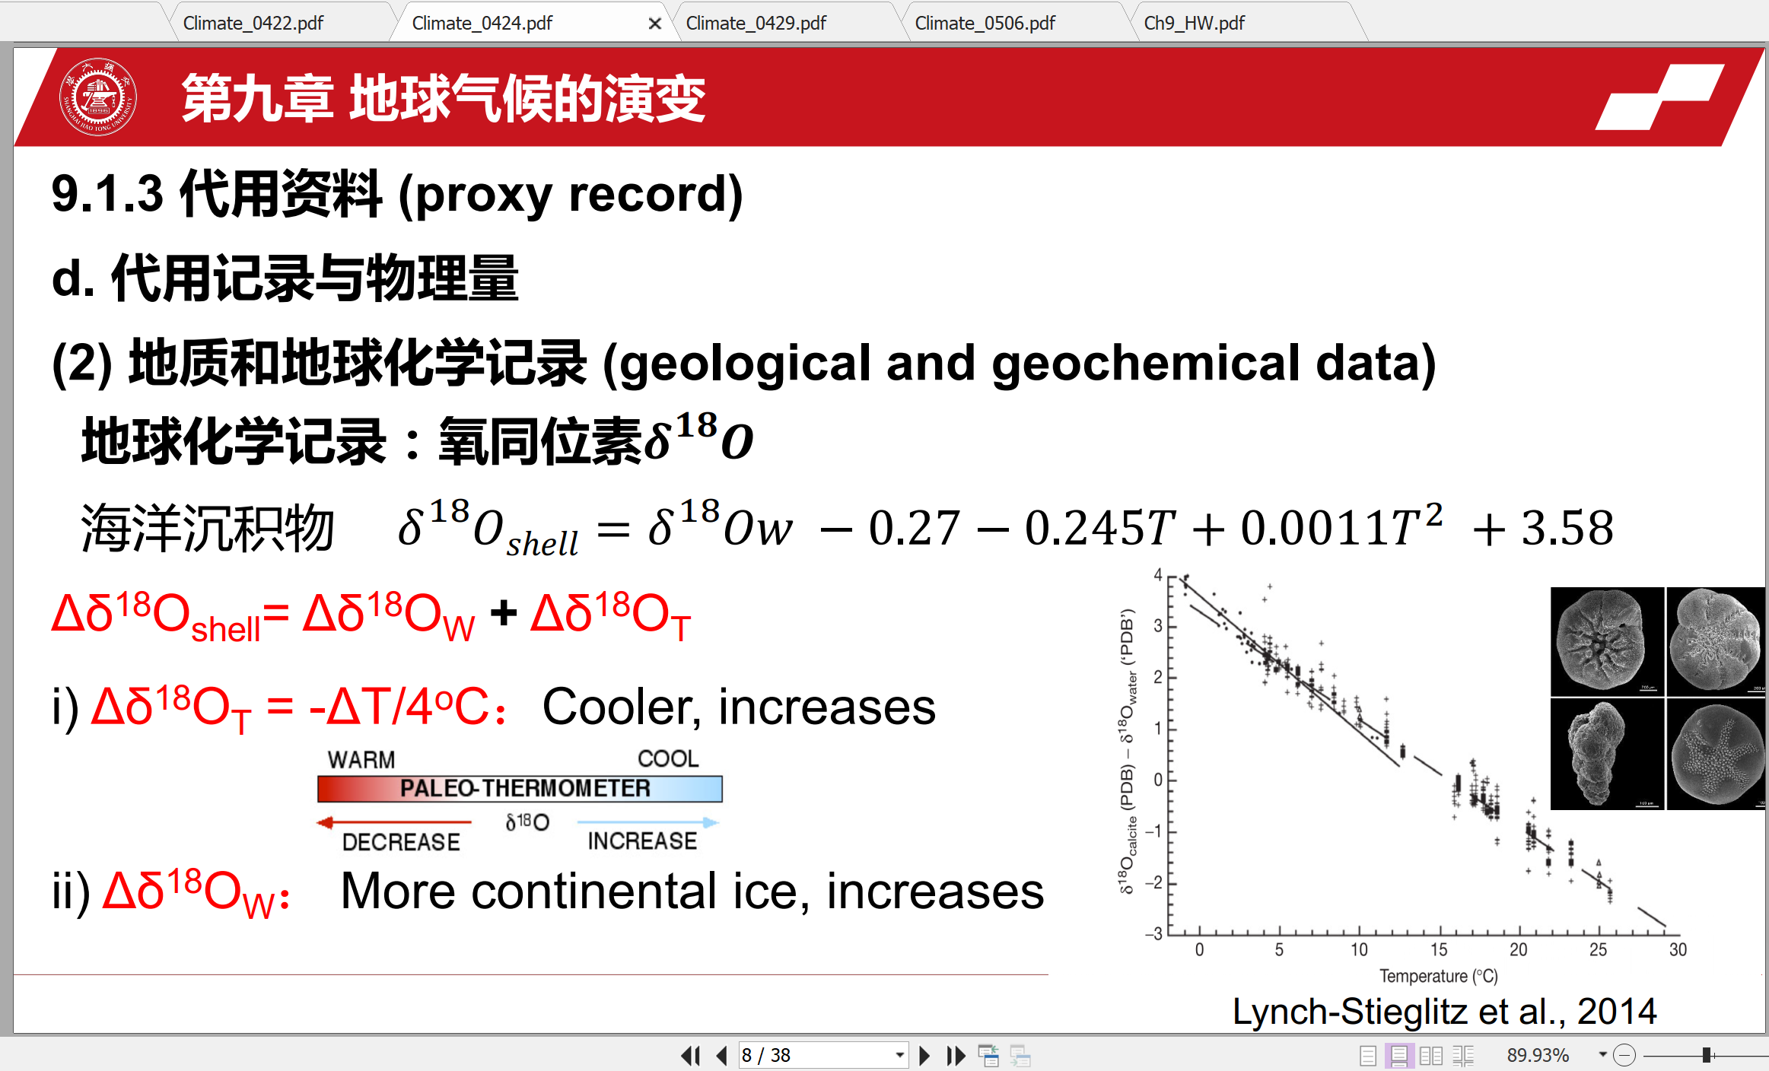

References